Name : Arshiya Tabassum A

Superset ID : 6424209

**WEEK 5**

**Sample Hands-on Exercises on Edge Services and API Gateway with Spring Boot 3 and Spring Cloud**

**Exercise 1: Implementing Edge Services for Routing and Filtering**

**EdgeGatewayServiceApplication.java**

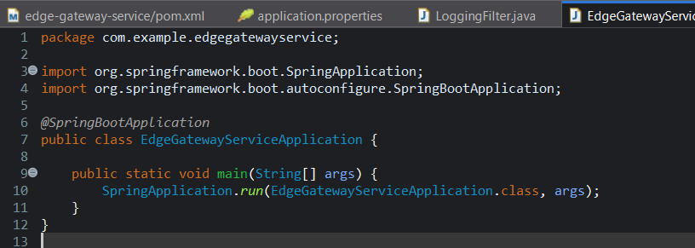

**LoggingFilter.java**

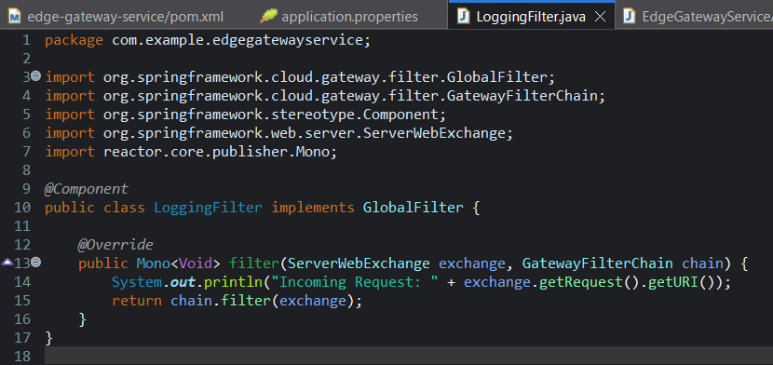

**Application.properties**

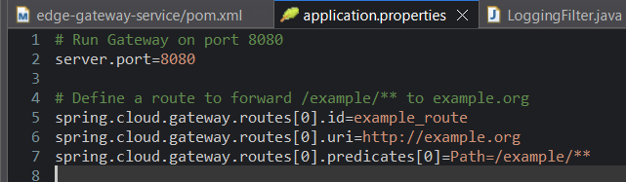

**Pom.xml**

<?xml version="1.0" encoding="UTF-8"?>

<project xmlns="http://maven.apache.org/POM/4.0.0"

xmlns:xsi="http://www.w3.org/2001/XMLSchema-instance"

xsi:schemaLocation="http://maven.apache.org/POM/4.0.0 https://maven.apache.org/xsd/maven-4.0.0.xsd">

<modelVersion>4.0.0</modelVersion>

<parent>

<groupId>org.springframework.boot</groupId>

<artifactId>spring-boot-starter-parent</artifactId>

<version>3.5.3</version>

<relativePath/> <!-- lookup parent from repository -->

</parent>

<groupId>com.example</groupId>

<artifactId>edge-gateway-service</artifactId>

<version>0.0.1-SNAPSHOT</version>

<name>edge-gateway-service</name>

<description>Spring Boot 3 Edge Gateway with Spring Cloud Gateway (Reactive)</description>

<properties>

<java.version>21</java.version>

<spring-cloud.version>2023.0.3</spring-cloud.version>

</properties>

<dependencies>

<!-- Actuator for monitoring -->

<dependency>

<groupId>org.springframework.boot</groupId>

<artifactId>spring-boot-starter-actuator</artifactId>

</dependency>

<!-- Use Reactive WebFlux instead of MVC -->

<dependency>

<groupId>org.springframework.boot</groupId>

<artifactId>spring-boot-starter-webflux</artifactId>

</dependency>

<!-- Spring Cloud Gateway (Reactive) -->

<dependency>

<groupId>org.springframework.cloud</groupId>

<artifactId>spring-cloud-starter-gateway</artifactId>

</dependency>

<!-- DevTools for Hot Reload -->

<dependency>

<groupId>org.springframework.boot</groupId>

<artifactId>spring-boot-devtools</artifactId>

<scope>runtime</scope>

<optional>true</optional>

</dependency>

<!-- Lombok (optional, for reducing boilerplate) -->

<dependency>

<groupId>org.projectlombok</groupId>

<artifactId>lombok</artifactId>

<optional>true</optional>

</dependency>

<!-- Testing -->

<dependency>

<groupId>org.springframework.boot</groupId>

<artifactId>spring-boot-starter-test</artifactId>

<scope>test</scope>

<exclusions>

<!-- Exclude JUnit Vintage since we're using JUnit 5 -->

<exclusion>

<groupId>org.junit.vintage</groupId>

<artifactId>junit-vintage-engine</artifactId>

</exclusion>

</exclusions>

</dependency>

</dependencies>

<dependencyManagement>

<dependencies>

<dependency>

<groupId>org.springframework.cloud</groupId>

<artifactId>spring-cloud-dependencies</artifactId>

<version>${spring-cloud.version}</version>

<type>pom</type>

<scope>import</scope>

</dependency>

</dependencies>

</dependencyManagement>

<build>

<plugins>

<plugin>

<groupId>org.springframework.boot</groupId>

<artifactId>spring-boot-maven-plugin</artifactId>

</plugin>

</plugins>

</build>

</project>

**Output :**

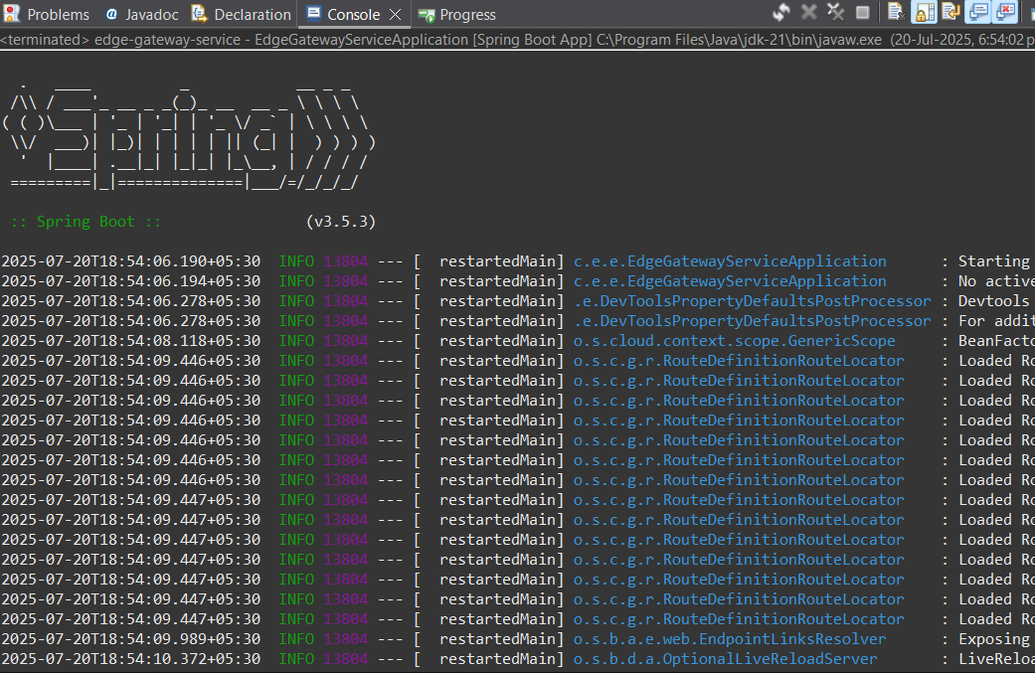

**Exercise 2: Load Balancing in an API Gateway**

**LoggingFilter.java**

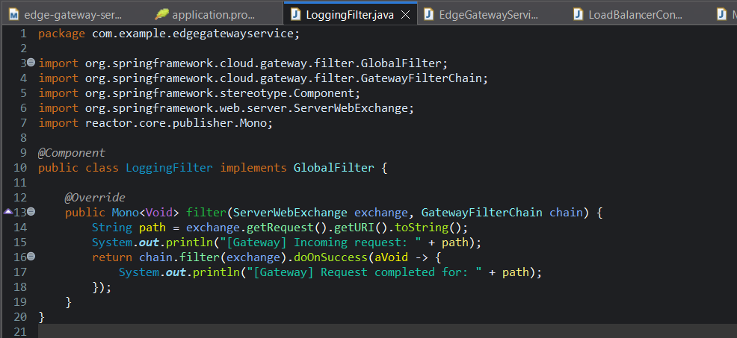

**MockServiceSupplier.java**

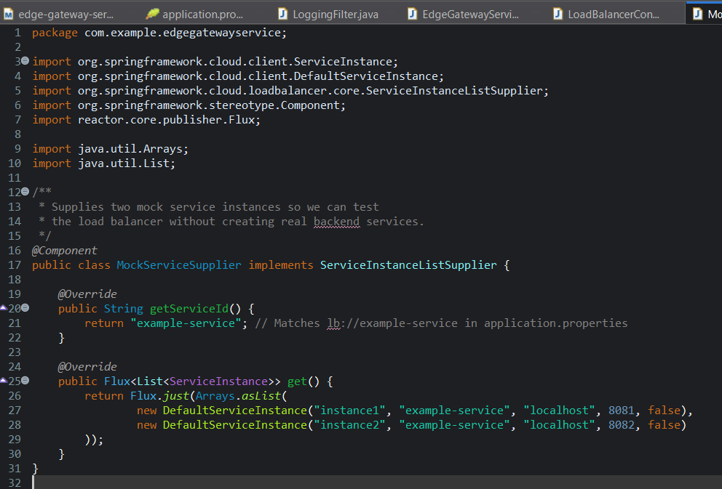

**Pom.xml**

<?xml version="1.0" encoding="UTF-8"?>

<project xmlns="http://maven.apache.org/POM/4.0.0"

xmlns:xsi="http://www.w3.org/2001/XMLSchema-instance"

xsi:schemaLocation="http://maven.apache.org/POM/4.0.0 https://maven.apache.org/xsd/maven-4.0.0.xsd">

<modelVersion>4.0.0</modelVersion>

<parent>

<groupId>org.springframework.boot</groupId>

<artifactId>spring-boot-starter-parent</artifactId>

<version>3.5.3</version>

<relativePath/> <!-- lookup parent from repository -->

</parent>

<groupId>com.example</groupId>

<artifactId>edge-gateway-service</artifactId>

<version>0.0.1-SNAPSHOT</version>

<name>edge-gateway-service</name>

<description>Spring Boot 3 Edge Gateway with Spring Cloud Gateway (Reactive + Load Balancing)</description>

<properties>

<java.version>21</java.version>

<spring-cloud.version>2023.0.3</spring-cloud.version>

</properties>

<dependencies>

<!-- Actuator for monitoring -->

<dependency>

<groupId>org.springframework.boot</groupId>

<artifactId>spring-boot-starter-actuator</artifactId>

</dependency>

<!-- Reactive WebFlux (needed for Gateway) -->

<dependency>

<groupId>org.springframework.boot</groupId>

<artifactId>spring-boot-starter-webflux</artifactId>

</dependency>

<!-- Spring Cloud Gateway (Reactive) -->

<dependency>

<groupId>org.springframework.cloud</groupId>

<artifactId>spring-cloud-starter-gateway</artifactId>

</dependency>

<!-- Spring Cloud LoadBalancer (for client-side load balancing) -->

<dependency>

<groupId>org.springframework.cloud</groupId>

<artifactId>spring-cloud-starter-loadbalancer</artifactId>

</dependency>

<!-- DevTools for Hot Reload -->

<dependency>

<groupId>org.springframework.boot</groupId>

<artifactId>spring-boot-devtools</artifactId>

<scope>runtime</scope>

<optional>true</optional>

</dependency>

<!-- Lombok (optional) -->

<dependency>

<groupId>org.projectlombok</groupId>

<artifactId>lombok</artifactId>

<optional>true</optional>

</dependency>

<!-- Testing -->

<dependency>

<groupId>org.springframework.boot</groupId>

<artifactId>spring-boot-starter-test</artifactId>

<scope>test</scope>

<exclusions>

<exclusion>

<groupId>org.junit.vintage</groupId>

<artifactId>junit-vintage-engine</artifactId>

</exclusion>

</exclusions>

</dependency>

</dependencies>

<dependencyManagement>

<dependencies>

<dependency>

<groupId>org.springframework.cloud</groupId>

<artifactId>spring-cloud-dependencies</artifactId>

<version>${spring-cloud.version}</version>

<type>pom</type>

<scope>import</scope>

</dependency>

</dependencies>

</dependencyManagement>

<build>

<plugins>

<plugin>

<groupId>org.springframework.boot</groupId>

<artifactId>spring-boot-maven-plugin</artifactId>

</plugin>

</plugins>

</build>

</project>

**Output :**

